React State & Styling

React State
React allows developers to create large web applications that can change data without reloading the page. React manages changes through the component's state and only changes parts of the page where the state changes. To put it plainly, the difference between props and state is whether you need external or internal management for your component. Props are what the component needs to receive to do its job, while the state is what it manages on its own.
Go over the Light Switch example to explore the state with the cohort or your pairs. Consult the comments in the JS file to help you understand what is happening.

The most important thing is that you understand the component in React and its connection to the HTML page. When you jump into your day of learning, review this 🎦past pair programming session on React states.
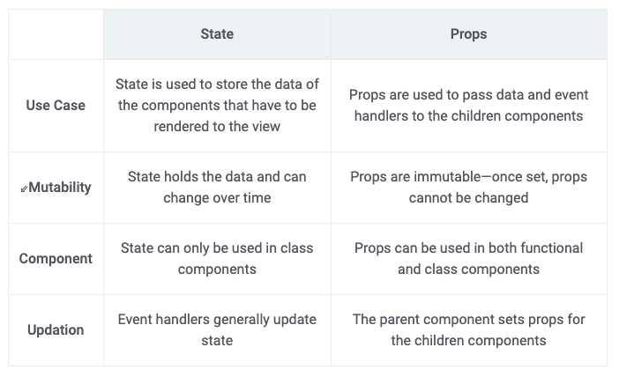
Styling in React
React only provides a virtual DOM, whereas the presentation part still lies with CSS. We recommend you start simple, using only ‘regular’ css, then transition into more advanced styling concepts that can make React unique (and sometimes seem daunting for beginners), like the library Styled Components

Specific Things To Learn
- Defining styles as objects, not as rules
- Importing stylesheets into React application.

CSS Topic: Buttons
Learn all the classes, colors, properties, effects, shapes, sizes, that you can customize on a button using CSS

Eloquent JS, make a delivery robot.
This chapter is a great exercise and will get you thinking about some good stuff. If you have time go ahead and try to do the full thing, it will be good practice, however, if you are feeling stressed for time just read the text and try to follow what is going on.

End-of-day questions:

React State
- What is the React state?
- What is the difference between React props and state?
- When to use React props
- When to use React state

EOD Quiz: React State & Style

